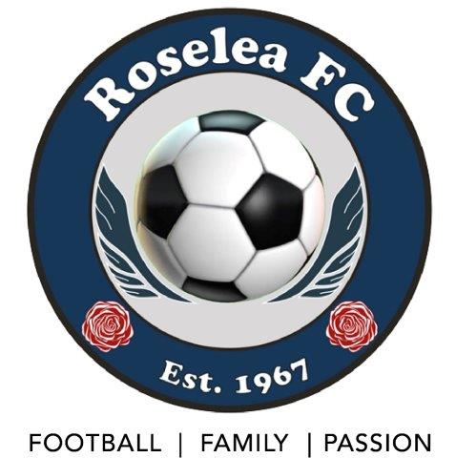

REGULATIONS
Roselea Football Club

As at 17 Sept 2021

PREAMBLE

The follow regulations are created under the authority of Rule 27.1 of the club constitution which states

27.1 Board to Formulate Regulations

The Board may formulate, issue, adopt, interpret and amend such Regulations for the proper advancement, management and administration of the Club and for the advancement of the Objects as it thinks necessary or desirable.

Such Regulations must be consistent with the Constitution.

REGULATIONS

Regulation 1:

The following policies and procedures are empowered as Regulations under this Constitution from the time of adopted by the Board until such time as they are formally updated, rescinded or superseded:

 | Policy or Procedure | Status | Date of Adoption
1 | Player Grading and Team Formation Policy | Published | Feb 2021
2 | Board Member: Delegated Expenditure Limits | Approved | Feb 2021
4 | Member Fee Refund Policy | Published | Jan 2021
 | Fees Rebate Policy (Inc Committee & Coaches Rebates) | Approved | Sept 2021
 | Fines Policy | Approved | Sept 2021
5 | Grievance Procedure | Draft under Consideration
6. | Disciplinary Procedure | Draft Under Consideration
 | Use of Club Social Media Policy | To be written
 | Privacy and Member Information Policy | To be written
7 | Team & Player Trophies and Recognition Awards | To be written
8 | Touring Team Support Policy | To be written

Regulation 2:

- The Portfolio responsibilities of the Club Directors shall be

POSITION | PORTFOLIO RESPONSIBILITY - ie Management of …
Club President, (Chair of Board)
Director, Club Development | Grants and major projects.  Club promotion and marketing  Sponsorship  Venue & facilities upgrades
Director, Player & Coach Development | All development programs (Internal and external) for players and coaches.  Player Gradings and team formations.  Coach performance throughout the season.
Director, Membership | All matters related to process and system of registering all players, officials and volunteers of the Club.  Reporting on the membership profile of the club
Director, Finance | Club budget and financial operations
Director, MiniRoos Football (Mixed) | All football matters for Mixed MiniRoos Teams (u6-u11)
Director, Senior Football (Mens) | All football matters for Mens teams u18s and older
Director, Junior Football (Mixed) | All football matters for Mixed Teams (u12 -u17s)
Director, Female Football | All football matters for Girls & Womens team
Director, Communications | Club Newsletter; C & M eNews; Social Media; Club Website
Director, Venues and Equipment | Playing & training venues; clubhouse & storage rooms, canteen operations; venue equipment; club training & playing equipment

- The Board may appoint a Club Administrative Officer, who may participate in Board Meetings for the purposes of effectively managing the affairs of the Club. Such an Administrative Officer shall not be a Board member and will not have a vote at Board Meetings.

Attendance at, and participation in, Board meetings by the Administrative Officer is totally at the discretion of the Board at that time.

Regulation 3:
CLUB GENERAL COMMITTEE
The Club General Committee will be an advisory and advocacy group only
The Club General Committee will have no fixed decision making or governance responsibility.
Each member of Club General Committee will report to a nominated member of the Board, or in the absence of such nominated Board Member, to the Club President
Each Club Director shall also be a member of the Club General Committee

The positions on the Club General Committee, and their nominated Board Director, shall include, but not be limited to …

- Registrars – MiniRoos, Juniors, Seniors & Womens (Director, Membership)

- Age Coordinators (Mixed) – u6-7; u8-9; u10-11 (Director MiniRoos)

- Webmaster ]
- Social Media Manager ] (Director, Marketing & Communications)
- Newsletter Editor ]
- Newsletter Editor ]

- Delegates to NWSF (and other organisations as required) ]
- Coordinator, Pre-Season Matches ] (President)

- Members of Sub-Committees & Special Projects Committees ] Various Directors

- Super League co-ordinator (Director, Senior Football)

- Gear Manager ]
- Equipment Manager ] (Director, Venues & Equipment)
- Venues & Canteens Coordinator ]

- MPIO (President)

- WWCC Compliance Officer - (President)

The full Club General Committee will convene as required, at the determination of the Board, but at least twice per year

- Pre-season each year to prepare for the immediate season ahead
- Post-season to review the season just completed and commence planning for the following season

